**Description of Slovenian non-EO dataset preparation for Perceptive Sentinel project**

Dataset description for internal use

**Draft version**

Ljubljana, 29.5.2018

**Description of Slovenian non-EO dataset preparation for Perceptive Sentinel project**

Dataset description for internal use

**Draft version**

**Prepared by:**

Janez Bergant[[1]](#footnote-1), Simon Ograjšek[[2]](#footnote-2)

Agricultural institute of Slovenia

**E:** info@kis.si

**http:** http://www.kis.si/en/

**Content**

[1 INTRODUCTION 2](#_Toc515533949)

[2 DATA OVERVIEW 2](#_Toc515533950)

[3 FIELD OPERATION AND TASK DATA 3](#_Toc515533951)

[3.1 Preparation 3](#_Toc515533952)

[Preparation steps 4](#_Toc515533953)

[Joining the data 4](#_Toc515533954)

[3.2 Spatial field operations/tasks dataset 6](#_Toc515533955)

[4 CROP TYPE AND YIELD DATA 6](#_Toc515533956)

[4.1 Preparation 6](#_Toc515533957)

[Preparation steps 7](#_Toc515533958)

[Joining the data 7](#_Toc515533959)

[4.2 Spatial yield dataset 7](#_Toc515533960)

[5 THE DATASET PACKAGE OF JABLJE 8](#_Toc515533961)

**Picture content**

[Picture 1: The location of Jablje fields. 2](#_Toc515533962)

[Picture 2: A part of joining steps of field operation data to spatial field dataset in ArcGIS model builder. 5](#_Toc515533963)

**Table content**

[Table 1: The code list of field operations. 3](#_Toc515533964)

[Table 2: The definition of column names for layer of field operations. 6](#_Toc515533965)

[Table 3: The definition of column names for layer of yields. 7](#_Toc515533966)

[Table 4: The detailed information on coordinate systems. 8](#_Toc515533967)

# INTRODUCTION

The document describes the first version of Slovenian non-EO data preparation steps and the structure of the non-EO dataset as it’s result. The non-EO data will be used as input into development of EO value added services (EO VAS), validation and demonstration activities in further work packages of Perceptive Sentinel project (WP3, WP4, WP6).

# DATA OVERVIEW

This is the first test version of the non-EO dataset for Slovenia. It contains the crop type, yield and management task/operation data for one part of the the Jablje[[3]](#footnote-3) agricultural fields for year 2017 (the data for year 2016 is still to come). The field borders were selected from LPIS crop type dataset for 2017.

D:\giPRO\2018-PerceptiveSentinel\Data\nonEO-data_priprava\Jable\Documentation\karte\manjse\Jablje_overview_map_obrezana.tif

Picture 1: The location of Jablje fields.

# FIELD OPERATION AND TASK DATA

## Preparation

Field operation tasks are collected by farmers which are applying to actions and operations from Rural Development Program (RDP) which is confirmed by European Commission for program period 2014 - 2020 (example: agri-environment scheme (AES), etc.). The purpose of RDP is to improve the biodiversity, water and soil resources, the competitiveness of the agricultural sector, social inclusion and the local development of rural areas. The RDP is the program basis for drawing on financial resources from the European Agricultural Fund for Rural Development. Farmers involved in one of the actions and operations from RDP are receiving subsidies. The field operation/tasks are collected by farmers for each field separately by fulfilling the [form](http://www.arsktrp.gov.si/fileadmin/arsktrp.gov.si/pageuploads/Aktualno/Aktualno/2018/Evidence_KOPOP_OBJAVLJENO_marec_2017.pdf) which is available online.

The field operation tasks for Jablje fields are being collected by our colleague from Infrastructural Centre of Jablje. The table contains the date, the type of field operation, the area where operation was carried out, crop type, crop variety and remarks. There are eleven operations in the code list.

Table 1: The code list of field operations.

|  |  |
| --- | --- |
| **Code** | **Task/field operation** |
| 1 | plowing |
| 2 | pre-sowing soil treatment |
| 3 | sowing / planting / transplanting |
| 4 | fertilization |
| 5 | mechanical weed control |
| 6 | covering with anti-insect nets or other coverages |
| 7 | plant protection measures |
| 8 | harvesting, mowing |
| 9 | mechanical destruction of the crop |
| 10 | soil sample for Nmin analysis |
| 11 | other work tasks |

The structure of the data from the [form](http://www.arsktrp.gov.si/fileadmin/arsktrp.gov.si/pageuploads/Aktualno/Aktualno/2018/Evidence_KOPOP_OBJAVLJENO_marec_2017.pdf) is directly not useful for the purpose of our project. There are two main issues in the current data that had to be overtaken:

* The data is **being collected separately for each LPIS parcel** (LPIS[[4]](#footnote-4) parcel means a continuous area of agricultural land with the same type of actual land use). In Slovenia the LPIS parcel is identified by ID number called **'GERK\_PID**'.)
* Operations have no column by which one can be joined to spatial field dataset. Furthermore inside each LPIS parcel the field operations can be related to different spatial level of LPIS parcel:

1. whole LPIS parcel,
2. to the part of the LPIS parcel with known spatial object (example: the part with the same crop type) or
3. to the part of the LPIS parcel with unknown spatial object.

Preparation steps

Therefore we had to do some data preparation steps. Since the field operation data is collected separately for each LPIS parcel, the data had to be re-arranged into one table with unified structure. Also we want field operations to be spatial dataset. Therefore we had to assign each record in the table of operations to which level of LPIS parcel it relates. We have designed a four-level precision principle; from LPIS parcel level (presented by column GERKime) to most detailed sub-parcel level (presented by column Parc\_level3). For each record in the operation data table we checked the data about crop type and the area on which the operation was carried out. Based on these information we assigned the *parcel ID* into the four columns used for further spatial joining. The *parcel ID* in the field operation table had to be the same as *parcel ID* in the spatial field dataset under “GERKime”, “Parcela”, “Parc\_nivo2” or “Parc\_nivo3”. We also added column “own\_locator”. When operations refered to the whole area of spatial object (polygon) from the field parcel dataset we assigned ‘Yes’ into “own\_locator” column or ‘No’ if operations was carried out only on the part of the spatial object, but we didn’t know exactly where.

We had to repeat the data preparation steps manually for each field operation.

Joining the data

The join was made on most detailed parcel level for which we could assign the operation. The final joining field with *parcel\_ID* is under the column “atr2field” of operation table. Column “joinlevel” is the description from which level the *parcel\_ID* was taken.

The table of field operation was separated into four tables based on level of joining and joined with the spatial field dataset. Example: The operations defined on LPIS parcel level were joined to spatial dataset delineated on level of LPIS parcel. The operations more precisely defined (level 1) were joined to field dataset delineated on level 1 of LPIS parcel. The ArcGIS 10.0 Make Query Table tool was used for the joining. This tool applies an SQL query to a database and the results are represented in a layer or table view. The query can be used to join several tables or return a subset of columns or rows from the original data in the database.

The results where four layers of field operations which we merged into one final layer of field operation data.

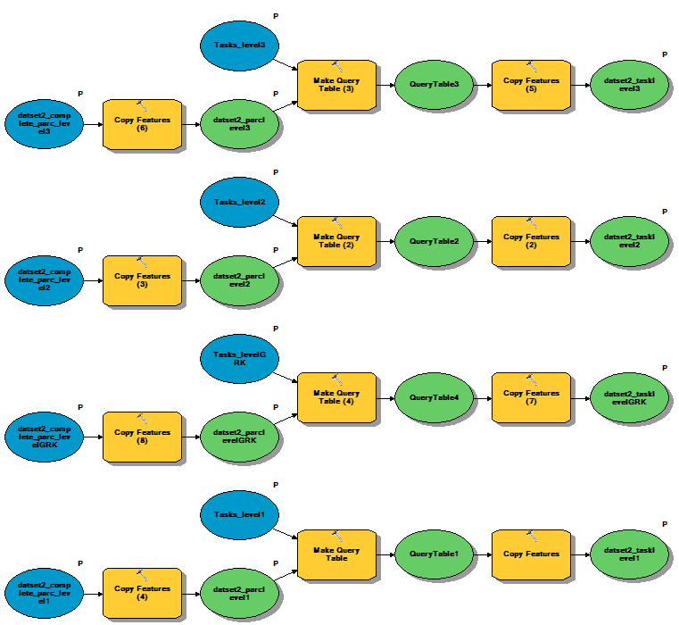

Picture 2: A part of joining steps of field operation data to spatial field dataset in ArcGIS model builder.

## Spatial field operations/tasks dataset

The dataset of field operations/tasks is the result of previously described preparation steps. It is spatial database or layer file in .shp format in Slovenian D48 coordinate system. Currently is named **datset2\_task\_arranged.**

Current version of spatial layer of field operations/tasks for 2017 covers an area of 275,82 ha out of 430,13 ha of Jablje fields (64 %). Layer has the attribute table.

Table 2: The definition of column names for layer of field operations.

|  |  |
| --- | --- |
| **Column** | **Definition** |
| OBJECTID | object ID |
| Shape | type of a shapefile (polygon) |
| Shape\_Length | the length of the object border m2 |
| Shape\_Area | the area of object in m2 |
| parcel\_name | the parcel ID (the joining field) |
| joinlevel | the level on which the operation was joined to spatial dataset |
| TASK\_code | the code of field operation \*a |
| ID\_task | ID of the task |
| task\_date | the date when task was carried out in format: *yyyymmdd* (example: 20170701) |
| own\_locator | does operation refer to the whole area of the feature object |
| DataProduced | The time that layer was produced |

\*a 🡪 The codes are defined in code list of field operations (Table 1).

# CROP TYPE AND YIELD DATA

## Preparation

The yield data collection is not an obligation for farmers involved in actions and operations from Rural Development Program (RDP). The yields for Jablje fields has been collected by our colleague from Infrastructural Centre of Jablje. The table contains the date of harvesting, parcel name, the crop type, crop variety and the yield (in kg).

Again there were issues in the current table of yields that had to be overtaken:

* The name of the parcels in parcel name column are not the same as the parcel name in the spatial field dataset.
* Yield table has no column by which one can be joined to spatial field dataset. Furthermore inside each LPIS parcel the yields refer to different spatial level of LPIS parcel:
* whole LPIS parcel,
* to the part of the LPIS parcel with known spatial object (example: the part with the same crop type)

Preparation steps

For each record in the yield table we checked the parcel name and date of harvesting, crop type, crop variety. We read the area for which the yield refered to from the field operations table on the matching date of harvesting. Based on combination of all these information we assigned the *parcel ID* into the four columns used for further spatial joining (the same as we did with field operations data9. The *parcel ID* in the yield table had to be the same as *parcel ID* in the spatial field dataset under “GERKime”, “Parcela”, “Parc\_nivo2” or “Parc\_nivo3”. Again we added column “own\_locator”.

We had to repeat the data preparation steps manually for each yield record.

Joining the data

The joining steps were quite similar as for the field operation data. The join was made on most detailed parcel level for which we could assign the yield. The final joining field with *parcel\_ID* is under the column “atr2field” of yield table. Column “joinlevel” is the description from which level the *parcel\_ID* was taken. Again the ArcGIS 10.0 Make Query Table tool was used for the joining. Yield layers were merged into one final yield layer.

## Spatial yield dataset

The yield dataset is the result of previously described preparation steps. It is spatial database or layer file **datset2\_yield\_arranged** in .shp format in Slovenian D48 coordinate system.

Current version of spatial yield dataset for 2017 covers an area of 272,01 ha out of 430,13 ha (63 %). Layer has the attribute table.

Table 3: The definition of column names for layer of yields.

|  |  |
| --- | --- |
| **Column** | **Definition** |
| OBJECTID | object ID |
| Shape | type of a shapefile (polygon) |
| Shape\_Length | the length of the object border m2 |
| Shape\_Area | the area of object in m2 |
| parcel\_name | the parcel ID (the joining field) |
| joinlevel | the level on which the yield was joined to spatial dataset |
| CROPT\_code | the code of crop types \*b |
| ID\_yieldgr | ID of the yield |
| yield\_date | the date when yield was harvested in format: *yyyymmdd* (example: 20170701) |
| yield\_tha | yield in t/ha for spatial object |
| DataProduced | The time that layer was produced |

b\* 🡪 the crop type codes are defined in crop type code list. The current version is available on Dropbox (<https://www.dropbox.com/home/PerceptiveSentinel-temporary/WP/WP2?preview=slovenian_lpis_sifrant.xls>)

# THE DATASET PACKAGE OF JABLJE

The dataset of Jablje is shared in zip. file **31052018** and contain these layers:

* datset2\_task\_arranged\_WGS84 🡪 the field operation/task layer of Jablje fields in WGS 84 coordinate system
* dataset2\_task\_arranged 🡪 the field operation/task layer of Jablje fields in D48 coordinate system
* datset2\_yield\_arranged\_WGS84 🡪 the yield layer of Jablje fields in WGS 84 coordinate system
* dataset2\_yield\_arranged 🡪 the yield layer of Jablje fields in D48 coordinate system

Table 4: The detailed information on coordinate systems.

|  |  |
| --- | --- |
| Spatial definition of D48 coordinate system | Spatial definition of WGS84 coordinate system |
| D48\_Slovenia\_TM.prj  Projection: Transverse\_Mercator  False\_Easting: 500000,000000  False\_Northing: -5000000,000000  Central\_Meridian: 15,000000  Scale\_Factor: 0,999900  Latitude\_Of\_Origin: 0,000000  Linear Unit: Meter (1,000000)  Geographic Coordinate System: GCS\_D48  Angular Unit: Degree (0,017453292519943299)  Prime Meridian: Greenwich (0,000000000000000000)  Datum: D\_D48  Spheroid: Bessel\_1841  Semimajor Axis: 6377397,155000000300000000  Semiminor Axis: 6356078,962818188600000000  Inverse Flattening: 299,152812799999990000 | WGS 1984 Web Mercator (Auxiliary Sphere).prj  Projection: Mercator\_Auxiliary\_Sphere  False\_Easting: 0,000000  False\_Northing: 0,000000  Central\_Meridian: 0,000000  Standard\_Parallel\_1: 0,000000  Auxiliary\_Sphere\_Type: 0,000000  Linear Unit: Meter (1,000000)  Geographic Coordinate System: GCS\_WGS\_1984  Angular Unit: Degree (0,017453292519943299)  Prime Meridian: Greenwich (0,000000000000000000)  Datum: D\_WGS\_1984  Spheroid: WGS\_1984  Semimajor Axis: 6378137,000000000000000000  Semiminor Axis: 6356752,314245179300000000  Inverse Flattening: 298,257223563000030000 |

1. AIS, Department of Agricultural Ecology and Natural Resources [↑](#footnote-ref-1)
2. AIS, Infrastructural Centre Jablje [↑](#footnote-ref-2)
3. Jablje are 430 ha of fields located 10 km north of Ljubljana and are a part of [**the Centre for Research and Trials**](http://kis.dev.splet1.si21.com/Center_za_raziskave_in_poskusnistvo) **of** Agricultural Institute of Slovenia. [↑](#footnote-ref-3)
4. LPIS stands for Graphic parcel information system. Provides up to date information for each participant about each agricultural table, indicating which areas are eligible, which payment entitlements can be requested, and what restrictions should be obeyed during the farming. [↑](#footnote-ref-4)